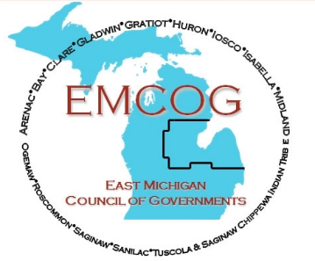

2025 EMCOG FULL COUNCIL – Governing Roster

NAME | ORGANIZATION | ECONOMIC INTERESTS
Lisa Salgat | Arenac County BOC | Public Official
Jennifer Pierson | Arenac County EDC | Workforce/Economic development
Vaughn Begick | Bay County BOC | BOC Liaison/Finance
Michael Duranzyk | Bay County BOC | Public Official
Lori Phelps | Clare County BOC | County Administrator
Robert Balzer | Consumers Energy | Private sector/Outreach
Karen Moore | Gladwin County BOC | Public official
Christopher Shannon | City of Gladwin | City Manager
Aaron DeSentz | City of Mt. Pleasant | City Manager
Tim Nieporte | Isabella County | County staff/Community Development Director
Brenda Bachelder | Region 7B | Workforce development
Catherine Sias | Village of Sanford | Grant writer
Robert Corrin | Chesaning Township | Township Official
Torrie Lee | Buena Vista Charter Township | Township Official
Michelle McGregor | Buena Vista Charter Township | Community Development Officer
Jamie Antku | Bridgeport Charter Township | Township Official
Chris Shannon | Bridgeport Charger Twp. | Township Manager
Ed McMasters | Spaulding Township | Township Official
Chuck Bennett | City of Brown City | City Manager
Tim Heiden | Village of Peck | Village Official
David Faber | City Manager | City Manager
Erik Rodriguez | Saginaw Chippewa Indian Tribe | Tribal staff/Public Relations
Frank Cloutier | Saginaw Chippewa Indian Tribe | Tribal Council
Zygmunt Dworzecki | Tuscola County | Citizen/At-large member
Debbie Powell | City of Cass City | City Manager
Willaim Mrdeza | City of Mt. Pleasant (Retired) | EMCOG Past Chair – Ex officio
- This Board is representative of the economic interests of the Region.
- The Regional Economic Development Team/CEDS Strategy Committee membership is authorized by the EMCOG Council as the approving body for the CEDS.

